Minutes of the Meeting of the Executive held on 19th January 2017 at Alfreton Leisure Centre.

Present: Mr. D. Whitlam (in the Chair), Mr. J. Hidle, Dr. B. May, Mr. P. Marshall, Mr. K. Davidson, Mr. R. Shepherd, Mr. T. Parr, Mr. P. Spink, Mrs. A. Basford. Mrs. H. Bickerstaff.

1) Apologies: Mrs. L. Bates, Mrs. M. Roberts.

2) Introduction

Helen Bickerstaff introduced herself as the new Regional Development Officer, replacing Emma Irlam-Carter.

3) Resignation of Mr. K. Davidson

At this point in the meeting, Mr. Davidson explained that he was resigning his position on the Executive, due to pressure of other demands on his time.

The meeting recorded its thanks for all his past efforts, including his six years as Chairman of the Association, and those on behalf of Derventio which had flourished under his Chairmanship.

Mr. Davidson then left the meeting.

4) Minutes of previous meeting.

It was agreed that the Minutes of the meeting of 17th November 2016 were a true record of that meeting.

5) Matters arising.

There were no matters arising which were not on the Agenda.

6) Finance Report

A report had been circulated ahead of the meeting and was accepted.
Generally, things were in line with the plan for the year end.

Against a budgeted deficit of £13k, the actual was currently £10.5k, with Spring Gala income still to come in. The £6.6 contribution towards the Regional development Officer had not yet been invoiced and would be to pay.

We would need to look at the pricing for the Long Course event as the financial picture was drifting steadily downwards.

The financial situation regarding the Development Plan, and latest County Records, were presented.

7) Competition Report

The Long Course Meet had completed satisfactorily.

Progress on the Spring Galas was on plan. The Draft Programme had been published and work was ongoing on the covers, programme notes, etc.

8) Development

Mrs. Roberts and Mrs. Bickerstaff had yet to meet.

The meeting was informed that Ashbourne and South Derbyshire Water Polo were no longer interested in maintaining SWIM21.

9) Talent

The meeting was told of the recent County Conference on Talent.

The Counties had been asked to put on three Camps, targeting up to 36 eleven year-olds, to be selected from Rankings after the end of the County Championships Window.

It was agreed to extend the published closing date for applications for the Coaching opportunities.

10) Disability

Nothing was reported.

11) Open Water

The new FINA Rules on minimum temperatures and the wearing of wet-suits were explained.

12) Water Polo

Members enquired about the situation of the previously sponsored competitions. Nothing was known at the time.

13) Moorways / Queens Leisure Centre update

A number of meetings held been held and it was clear that the cost of keeping Moorways open was unsustainable.

The Council had offered partial use of the Gala Pool at QLC on five evenings per week, 6 -8 pm Monday to Friday, to be shared between City of Derby and Derventio.
It was still intended that the family pool would re-open in June.

It was the Council’s view that costs already incurred was the clubs’ problem, but that they would help where they could. The clubs, on the other hand, had no hope of funding the numbers involved which worked out at around £150k even after transfer of a proportion of the QLC budget. The clubs had been asking for costs, unsuccessfully, for some time and nothing had been forthcoming until near the end of 2016.

14) Regional Update

Nothing new was reported.

15) Any Other Business

The meeting was advised that the process for payment for Timekeeper courses had changed, and that the Association would need to pay by BACS or Paypal. An Officials meeting would be discussing J1 and J2 courses.

It was agreed that the AGM would be held on Sunday, 18th June at Alfreton, and that Contemporaneous Issues and FINA Rules Update courses be arranged on the same day.

Arrangements were in hand for at least two of the ex-Chesterfield timing boards to be transferred to QLC by the next weekend. They were slightly narrower, leaving a small gap at each side. There was also a spare console unit. Matlock pool now had two good start units.

Members were concerned that they had not seen any approach for Officials for the Spring Galas. It was agreed that we would take Trainee Officials, but that Mr. Shepherd needed to know so that we were sure they could be accommodated. We would pay expenses for them on the same 40p per mile basis as working Officials.
Meals would be provided for those working in the session on each side of the break.

The meeting was advised that Lewis White had set a new British Record, subject to successful application and ratification.

Use of the system for review of County Records was discussed.

16) Date of next Executive meeting:

7:05pm. Thursday, 9th March, 2017 at Kings Chambers, Derby.

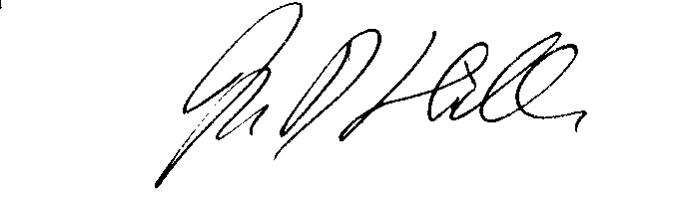

John Hidle
Hon. Secretary

